SPRUCE CREEK FALL NO FRILLS COMPETITIVE TRAIL RIDE
September 16-17, 2017 25 MILE CTR with Two Introductory Rides (12.5 each)
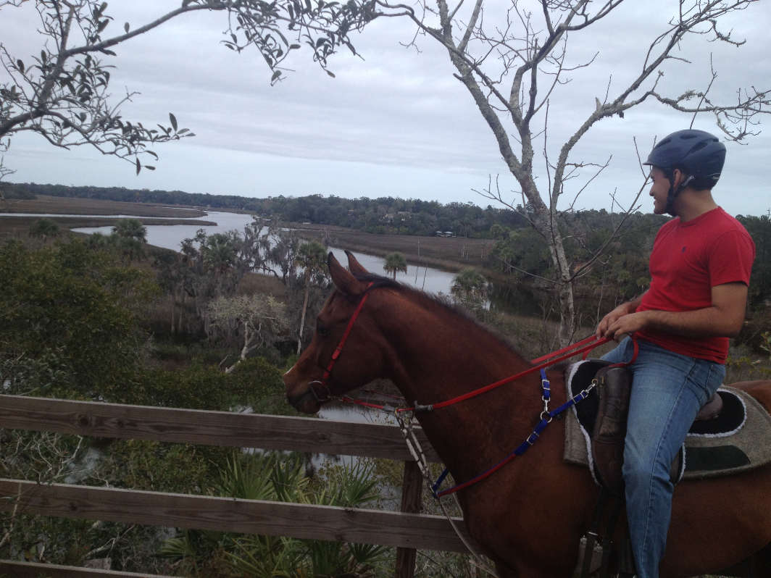

TRAILHEAD: Doris Leeper Spruce Creek Preserve 2317 Creek Shore Trail, New Smyrna, FL 32168 (ENTER AT ORANGE FOREST GATE)
Ride Manager: Ed Oathout 352.636.1840 Ride Secretary: Cheryl Van Deusen, 386.566.4820 cvandeusen@gmail.com

NEW FOR FALL 2017 – LICENSED MASSAGE THERAPIST AVAILABLE –Chris Keck - 904-477-2930 – Call or text her to schedule a chair massage in advance! She will be on site Saturday.

RIDE REQUIREMENTS: Entries are open to all breeds of horses or mules 4 years of age and older as of ride date for the CTR 25. Entries must be accompanied by your total entry fees and signed release. Last day to cancel and receive a full refund is September 1, 2017. Refunds will have a $25.00 office fee deducted and will not be mailed until after the ride date.

**25 Milers and Introductory Riders: Check in on Saturday afternoon and ride 25 miles or Into Ride(s) on Sunday. MILEAGE ONLY HORSES FOR ANY DISTANCE MAY COME THE MORNING OF RIDE WITH ADVANCE APPROVAL OF MANAGEMENT but all others (except Introductory Riders) must arrive the day before the ride starts and camp out with your horse! JUNIOR RIDERS: Riders under the age of 18 will compete in the Junior Division. It is the responsibility of the parent or guardian to ensure that Juniors 16 and under must be accompanied on the ride at all times by a parent or designated sponsor. Sponsor forms must be signed by sponsor before the ride begins.
RIDE RULES: This is a SEDRA sanctioned ride. All SEDRA rules will apply including but not limited to the following:

ALL RIDERS MUST WEAR A HELMET WHEN MOUNTED. EXTERNAL AIDS: Only water and grooming aids may be used; no hoof dressings, ointments, salves or other medications may be used except as authorized the judges. No boots or other protective devices may be used on the horse’s legs unless you are riding mileage only. No restriction on shoeing. Easyboots may be used.
DRUGS AND MEDICATIONS: No horse competing shall be given an illegal drug or medication for the purpose of altering the horse’s performance. Illegal drugs are defined as, but not limited to, any stimulant, depressant, tranquilizer, local anesthetic, anti-inflammatory or analgesic (including Bute and Banamine) or any medication that alters the distribution of body fluids. The finding of a drug or its by-product in the blood, urine or saliva of a horse will be used as evidence that such was illegally administered. There will be random drug testing using SEDRA rules. SEDRA RULES CAN BE FOUND ON THEIR WEB SITE: www.distanceriding.org
WATER: No hoses are allowed to be used on horses after you have vetted in. Mandatory holds will be at base camp. Riders may put out bucket, hay etc. in the designated area for the mandatory hold and CRI at the end of the ride.
WARNING RIBBONS: A red ribbon must be worn in the tail of any known (or suspected) kicker. All stallions must wear a yellow ribbon. Ribbons should be securely fastened into the tail. It is the rider’s responsibility to furnish their own ribbons. Rookies wear green please!
AWARDS: Completion and six places in each weight division, plus Grand and Reserve Champions of the ride. Juniors have their own division and are not eligible for Grand or Reserve. Proof of a horse’s registration is required to be eligible for breed awards. No Exceptions
CHECK IN AND VET IN: Registration will open at 3:00 PM on Saturday for 25 Milers and Intro Riders. Vet in will begin at 4:00 PM, subject to change as there are endurance rides on Saturday. The judges will examine your horse in hand and at the trot. Any faults, blemishes or unsoundness must be noted on your scoresheets and evaluated for starting at that time. Please plan to attend Ride Meeting to be aware of any updates.

TRAIL TERRAIN: The Doris Leeper Spruce Creek Preserve consists of more than 2200 acres in Volusia County, FL of which this 600 acre area consists of a mosaic of varying habitat and soil types. The trails are flat and sandy WITH SOME ROOTS. The trail is interesting terrain, including some two track trails and single track trails. Any rider going off trail MUST return to the SAME point where he/she left the trail to continue. You may not advance forward on foot, only mounted. Failure to do so will result in disqualification.
STARTING ORDER: Your number MAY be your starting order. Numbers may be assigned in the order in which entries are received although we may set up groups who wish to ride together. If you want, you may request a LATER starting position on your entry form, but not an earlier one. The ride starts at 7:00 am ESTIMATED (or at the discretion of ride management). Juniors may leave with their sponsors. Riders must display their numbers at their campsite also.
TIME ALLOWED: A range of 3:55 and 4:40 is the normal time allowed to complete SEDRA 25 miles without penalty; which includes one 20 minute P&R/safety mandatory hold. Time includes all vet and water stops. Any rider more than 30 minutes late (or early) will be disqualified. All checks will be in camp. NO SMOKING ON THE TRAILS! Introductory Riders will have 3 hours to complete the loop.
CAMPING: Primitive Camping ONLY -No electric available. Bring your own PEOPLE water – there is horse water available. Portable Paddocks or High-Ties may be utilized. The equestrian campsite is primitive with open fields and giant oak trees. There is ONE hose that is near the vet check area. All vet checks are in camp. Please do not tie directly to trees or fences! NO ELECTRICITY OTHER THAN YOUR GENERATORS – (which must be off between 10 pm-5:30 am.) Bring your own LANTERNS, AND/OR FLASHLIGHTS. All rules of the preserve must be observed. Anyone breaking these rules may be asked to leave. No firearms or narcotics are permitted in the preserve. Please leave the grounds as clean as you found them – remove or spread hay, and really spread the manure! A convenience store is four miles away. GATE closes at 9 pm so please keep the gate closed if you leave/enter the park after that time. ALL DOGS MUST BE KEPT ON A LEASH OR IN A KENNEL. NO DOGS ARE ALLOWED at meals or meetings, PLEASE. YOU MUST CLEAN UP YOUR CAMPSITE OR WE MAY CHARGE YOU $25 SO THAT WE ARE WELCOME BACK!
FOOD: Dinner will be provided for Riders, Officials, and Volunteers on Saturday night. Others may purchase a meal ticket for $8.00. Trail snacks will be provided on Sunday. Coffee and rolls/muffins are provided Sunday morning.

DIRECTIONS:

From I-95, take exit #249 New Smyrna Beach, SR #44 – Go east about 0.4 miles towards New Smyrna and take the FIRST left at caution light onto Sugar Mill Road. In 1.4 miles, Sugar Mill Road comes to a 4 way stop sign. Go left onto Pioneer Trail for 1.7 miles. Go right onto Turnbull Bay Trail. Go 2.1 miles and turn left onto Creek Shore Trail. The entrance to the preserve is 1.4 miles on left through an orange ‘forest’ gate.

From I-4 take exit 118, SR #44 East towards New Smyrna Beach. In about 7.2 miles turn LEFT onto CR 4118 which is Pioneer Trail. In about 4 miles, you come to a 4 way intersection (Cabbage Patch Sopotnik’s Bar on left corner. Stop and continue STRAIGHT still on Pioneer Trail, CR 4118. Go 4.1 miles (go over I95 but there is no exit there) to QUICK LEFT ON CURVE - Turnbull Bay Road. Go 2.1 miles and turn left onto Creek Shore Trail. The entrance to the preserve is 1.4 miles on the left through an orange ‘forest’ gate.

SPRUCE CREEK FALL NO FRILLS COMPETITIVE TRAIL RIDE
September 16-17, 2017 25 MILE CTR with Introductory Ride(s)
Remember, we have endurance and intro rides on Saturday if you want to come to both!

RIDER’S NAME______________________________________________________________________JUNIOR’S AGE____________

COMPLETE ADDRESS________________________________________________________________________________________

HOME PHONE____________________CELL PHONE___________________EMAIL_______________________________________

NAME OF SUNDAY HORSE________________________________________AGE____COLOR______________SEX______________

REGISTERED BREED________________________________________REGISTRATION #__________________________________

OWNER NAME, IF DIFFERENT__________________________________________________________________________________

SEDRA RIDER #_________________SEDRA HORSE #_______________

REQUIRED: COGGINS DATE PULLED:__________________________ ACCESSION NUMBER;____________________________

LAB:________________________________________________________________________________________________________

PLEASE CHECK ANY THAT APPLY: JUNIOR______ ROOKIE HORSE________ ROOKIE RIDER__________

Please note Rookie Horse or Rider –never completed 25 miles or more on ANY Sanctioned Ride, CTR or endurance.

Entry includes: Dinner the night before your ride. Coffee & Rolls and Trail snacks are provided on Sunday. Last day to cancel for refund is September 1, 2017. Refunds will have a $25.00 office fee deducted and will not be mailed until after the ride dates. For discount to apply, JUNIOR FEES must be sent in with their SPONSOR’s entry! ANY ONE WHO WISHES TO SEND IN TWO CHECKS, WE CAN WORK OUT A PAYMENT SCHEDULE WITH YOU. We understand cash flow and riders have choices!

**ENTRY FEE (25 MILERS) Sunday $ 100.00 _______________
Jr with paid sponsor 25 Mile Sunday $ 75.00 _______________
**ENTRY FEE INTRO RIDE $ 65.00 _______________
CAMPING FEE-$15 PER NIGHT for early arrival/late departure (includes 1 night) _______________
SEDRA NON-MEMBER Fee for 25 mile ride 5.00 _______________
ADDITIONAL DINNERS each night per person 8.00 _______________
Introductory Riders SEDRA fee if not a SEDRA member 1.00 _______________

LATE FEE IF NOT RECEIVED BEFORE 9/1/2017 $ 25.00 _______________

TOTAL $ ________________

Please make checks payable to Central FL Horse Shows and mail completed application, release and fees to:
Cheryl Van Deusen, 656 Sapp Road, New Smyrna Beach, FL 32168
Call 386.566.4820 or cvandeusen@gmail.com if questions!

Ride Release Form (Please read carefully and sign).
.
As consideration for participating in the Scenic Spruce Creek No Frills Rides, I agree to abide by the rules of the SEDRA and the Ride. I understand that distance riding involves being in remote areas for extended periods of time, far from communications, transportation, and medical facilities; that these areas have many natural and man-made hazards, which ride management cannot anticipate, identify, modify, or eliminate; that horses can be excitable, difficult to control, and unpredictable, and that accidents can happen to anyone at any time. I agree to take full responsibility for myself and the animal I am riding. This release is also valid for all of my animals, personal belongings, family members and any guest in my company.
I shall hold the following list of individuals and entities blameless and free from liability, to the fullest extent allowed by law, for any accident, injury or loss that might occur due to my participation in the ride. To be very clear, I shall not pursue any legal action or other form of action against the following: the ride management, Central Florida Horse Shows, Volusia County, all ride personnel, all veterinarians and related treatments, the State of Florida, the landowners of the base camp, and all property owners over whose land the ride crosses. I have read and understand this liability release. I understand that this Release applies for the entire ride; from arrival at Spruce Creek Preserve, during the ride and until removal of all animals and personal property from the ride site.

I HAVE READ, UNDERSTAND AND ACCEPT THIS RELEASE.

Signature of Rider______________________________________________________Date________________________________

Printed Name of Rider__________________________________________________________________________________________

Signature of Horse Owner (if different)_____________________________________________Date_______________

Printed Name of Horse Owner (if different)_____________________________________________________________

Signature of Parent/Guardian (Juniors under 18)_____________________________________Date_______________

Printed Name of Parent/Guardian for Junior Rider_______________________________________________________

Signature of Sponsor for Junior Rider______________________________________________Date_______________

Printed Name of Sponsor for Junior Rider___________________________________________Date_______________

