Scenic Spruce Creek Spring Fling Endurance
25/50 & INTRO RIDES SATURDAY May 19, 2018
(CTR next day)
Doris Leeper Spruce Creek Preserve, 2317 Creek Shore Trail
New Smyrna, FL Sanctioned by AERC, SERA, & SEDRA
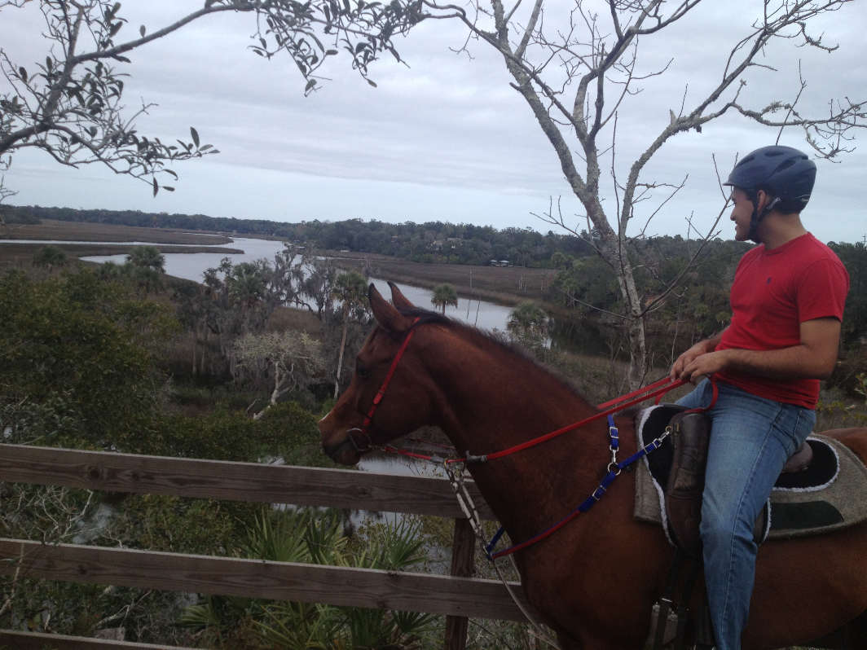
Send entries to: Cheryl Van Deusen (386) 566-4820 cvandeusen@gmail.com
656 Sapp Road
New Smyrna Beach, FL 32168

Facilities: The Doris Leeper Spruce Creek Preserve consists of more than 2200 acres in Volusia County, FL of
which this 600 acre area consists of a mosaic of varying habitat and soil types. Primitive Camping-No electric
available. There is plenty of grassy pasture with open fields and areas under wonderful old trees. Bring your
PEOPLE water – there is horse water available. Portable Paddocks or High-Ties may be utilized. There is ONE
hose that is near the vet check area. Please do not tie directly to trees or fences!

Entry Requirements: Pre-entry preferred for all rides with a $25.00 non-refundable deposit. You do not have to
send in full payment. Late fee will be charged if not pre-registered—post marked or emailed to me by
May 8, 2018. We want to be rider friendly but we have to have enough food & vets!
Rules: All AERC, SEDRA and SERA rules apply. Decisions of the vets are final. In order to receive credit for completing the ride, horses must be “fit to continue”, as determined by the veterinarians. The winner of the LD rides will be the first horse whose pulse recovers to 60 bpm. At registration, you must present ALL appropriate membership cards and negative coggins within one year. JUNIORS: must wear an approved helmet, and be accompanied by an adult sponsor 18 years or older. Everyone must show a current AERC card or pay the $15 non-member fee. **The $15.00 non-member fee applies to junior riders also.**
25 mile horses must be 48 months old, 50 horses must be 60 months old
ALL RIDERS (NOT JUST JUNIORS) MUST WEAR HELMETS WHEN MOUNTED .
Lastly, please be kind to volunteers and officials, without them we couldn’t have these rides!

FEES: Early Registration Fee AERC 25/50 miles $125.00 Adults; young riders are $90; Junior are $75 and Intro Riders $65.00 – This includes TWO nights of camping and rider meals (pot luck Friday, Saturday dinner). After the endurance rides on Saturday, there is a 25 mile CTR Sunday. $10 Discount if you ride two rides. ONCE YOU VET IN, THERE ARE NO REFUNDS. We have two intro rides each day.
Tentative Schedule of Events: Registration Opens Friday 3:00 PM, Vet In – Estimated 5:00 PM
Ride Meeting & POT LUCK DINNER Fri Estimated 7:00 PM; 50 Mile ride starts 6:30 am and 25 mile ride starts at 7:00 am although we may start them together. Check in with timer 15 minutes BEFORE your start. You can leave late but check-in! Ride Dinner/Awards Sat 6:30 PM Estimated, Times, officials and loops subject to change check on-site!!
Facilities: NO ELECTRICITY OTHER THAN YOUR GENERATORS – Bring your own LANTERNS, AND/OR
FLASHLIGHTS. All rules of the preserve must be observed. Anyone breaking these rules may be asked to
leave. No firearms or narcotics are permitted in the preserve. Please leave the grounds as clean as you found
them – remove or spread hay, and really spread the manure! A convenience store is four miles away. FOREST
GATE closes at 9 pm so please keep the gate closed if you leave/enter the park after that time. No camping
before Friday, after 10:00 am unless you make advance arrangements confirmed in writing. Primitive
camping included for two nights; Dogs are welcome, but must be under control/on a leash at all times!!! Your dog
should be contained while you are riding and not a nuisance to anyone or any other animals, PLEASE DO NOT
BRING THEM TO MEALS. Generators must be OFF between 10:00 pm-5:30 am. Ride management
reserves the right to CUT-OFF your generator if you are not there to cut it off!
Awards: Awards ceremony for the 25/50 mile riders will be done Saturday evening. Best condition, top
ten, and first Junior awards and completion awards.
Trails: All trails loop back to camp with no away vet checks. Sandy trails, predominantly two-track with
some single track through the woods and some dirt roads and roots! It is a barefoot friendly trail,
although many are new trails with cut timber and roots. These are MULTI-USE trails – the PERMANETNLY
MARKED BLUE TRAILS are for bicycles and there are pedestrians and dogs! YOU SHOULD never be on a
permanently marked blue trail and please be courteous to all other trail users so we are welcome back.
Meals: On Friday, we will provide Chicken and we ask that all endurance riders and guests bring a
covered dish to share! We feed you the NIGHT of the ride (Saturday) --which is included in your ride
entry. Anyone desiring an extra meal ticket can purchase extras for $8.00. This is a fair charge, so please
pay for your extra friends, family and crew! Directions: IF YOU USE GPS, YOU MUST TURN AT THE
ORANGE FOREST GATE when you see ride sign. 2317 CREEK SHORE TRAIL, NEW SMYRNA, FL

From I-95, take exit #249 New Smyrna Beach, SR #44 – Go east about 0.4 miles towards New Smyrna and take the FIRST left at caution light onto Sugar Mill Road. In 1.4 miles, Sugar Mill Road comes to a 4 way stop sign. Go left onto Pioneer Trail for 1.7 miles. Go right onto Turnbull Bay Road. Go 2.1 miles and turn left onto Creek Shore Trail. The entrance to the preserve is 1.4 miles on left through an orange ‘forest’ gate.

From I-4 take exit 118, SR #44 East towards New Smyrna Beach. In about 7.2 miles turn LEFT onto CR 4118 which is Pioneer Trail. In about 4 miles, you come to a 4 way intersection (Cabbage Patch Sopotnik’s Bar on left corner. Stop and continue STRAIGHT still on Pioneer Trail, CR 4118. Go 4.1 miles (go over I95 but there is no exit there) to QUICK LEFT ON CURVE - Turnbull Bay Road. Go 2.1 miles and turn left onto Creek Shore Trail. The entrance to the preserve is 1.4 miles on the left through an orange ‘forest’ gate.
Scenic Spruce Creek No Frills Spring Endurance Rides 25 and 50 miles
Sanctioned by AERC, SERA, and SEDRA
Rider’s Name:_____________________________________Cell phone:_______________________
Address:_______________________________________________AERC #____________________
City, State, Zip:____________________________________________________________________
Email:___________________________________________________________________________
Coggins LAB & Date Pulled:__________________________________Accession#____________
Coggins LAB & Date Pulled:__________________________________Accession#____________
Horse Owner’s Name (if different)_____________________________________________________
Date of Birth for Juniors only:______________________Weight Division or JR:_________________
Juniors (up to 16) must be at least 8 years old and be accompanied by an adult sponsor (21 yrs. Old+).
ALL NON–A.E.R.C. MEMBERS MUST PAY THE NON-MEMBER FEE OF $15.00- including Juniors! Must show current membership card or pay non-member fee;
SERA Member  Yes No | SEDRA Member  Yes No |  | WEIGHT DIVISION FOR 50 MILE RIDE - Featherweight (up to 160 lbs.)_____  Lightweight (161 to 185 lbs.)_______ Middleweight (186 to 210 lbs.)_____  Heavyweight ( 211 lbs. and up)_____ Junior________________
Saturday  AM | Intro Ride | Horse AERC # |  | Horse Name | Breed | Age | Color | Sex
Saturday  AM | Distance  25 | Horse AERC# |  | Horse Name | Breed | Age | Color | Sex | Owner’s Name
Saturday  AM | Distance  50 | Horse AERC# |  | Horse Name | Breed | Age | Color | Sex

{ }25 mile ride Adult – Saturday AM $125.00 __________
{ } 50 mile ride Adult $125.00 __________ YOUNG RIDERS:
{ }25 mile ride Junior Rider <16 years AM $ 75.00 __________ $90.00 _______ 25
$90.00 _______ 50
{ }50 mile ride Junior Rider <16 years $ 75.00 __________
{ } Intro rider any age $ 65.00 __________
{ } AERC Non-member fee $ 15.00 __________
{ } Meals for non riders $ 8.00 __________
{ } Early arrival camping $15 per night $15.00 __________
LATE FEE $35 if NOT POSTMARKED by 5/8/18 $ 30.00 __________
(or send an email with horse rider aerc # and commitment to pay $25 deposit by 5/8/18)
Adults, if you ride two rides, second ride is $10 less -$10.00 __________
Deposit if paid ($25) -$ __________
Balance due at registration $ ________________
CHECKS MADE OUT TO: Central FL Horse Shows
Mail to: Cheryl Van Deusen
656 Sapp Road
New Smyrna, FL 32168
386.566.4820 cvandeusen@gmail.com
Ride Release Form (Please read carefully and sign).

As consideration for participating in the Scenic Spruce Creek No Frills Rides, I agree to abide by the rules of the SEDRA, AERC, SERA, and the Ride. I understand that distance riding involves being in remote areas for extended periods of time, far from communications, transportation, and medical facilities; that these areas have many natural and man-made hazards, which ride management cannot anticipate, identify, modify, or eliminate; that horses can be excitable, difficult to control, and unpredictable, and that accidents can happen to anyone at any time. I agree to take full responsibility for myself and the animal I am riding. This release is also valid for all of my animals, personal belongings, family members and any guest or family member in my company.
I shall hold the following list of individuals and entities blameless and free from liability, to the fullest extent allowed by law, for any accident, injury or loss that might occur due to my participation in the ride. To be very clear, I shall not pursue any legal action or other form of action against the following: the ride management, Central Florida Horse Shows, Volusia County, all ride personnel, all veterinarians and related treatments, the State of Florida, the landowners of the base camp, and all property owners over whose land the ride crosses. I have read and understand this liability release. I understand that this Release applies for the entire ride; from arrival at Spruce Creek Preserve, during the ride and until removal of all animals and personal property from the ride site.

I HAVE READ, UNDERSTAND AND ACCEPT THIS RELEASE.
Signature of Rider_______________________________________Date_________________

Printed Name of Rider__________________________Date_________________

Signature of Horse Owner (if different)____________________Date__________

Printed Name of Horse Owner (if different)_______________Date____________

Signature of Parent/Guardian of Juniors ________________Date____________

Printed Name of Parent/Guardian of Juniors___________________Date______

Signature of Sponsor for Junior_____________________Date______________

Printed Name of Sponsor for Junior_________________Date_______________

