**2023 Broxton Bridge: Night Riders!**

**Friday July 14 AERC (SERA/SEDRA) 25, 50, 65, 75 Intro and CEI 1*, CEI 2* + YJ divisions**

**Saturday July 15 AERC (SERA/SEDRA) 25, 50 + Intro**

**ALL ENTRIES & PAYMENTS MUST BE RECEIVED by 5 July 2023**

All entries submitted online here _______________________(Eric provide)

register online, mail in full payment or **Zelle**

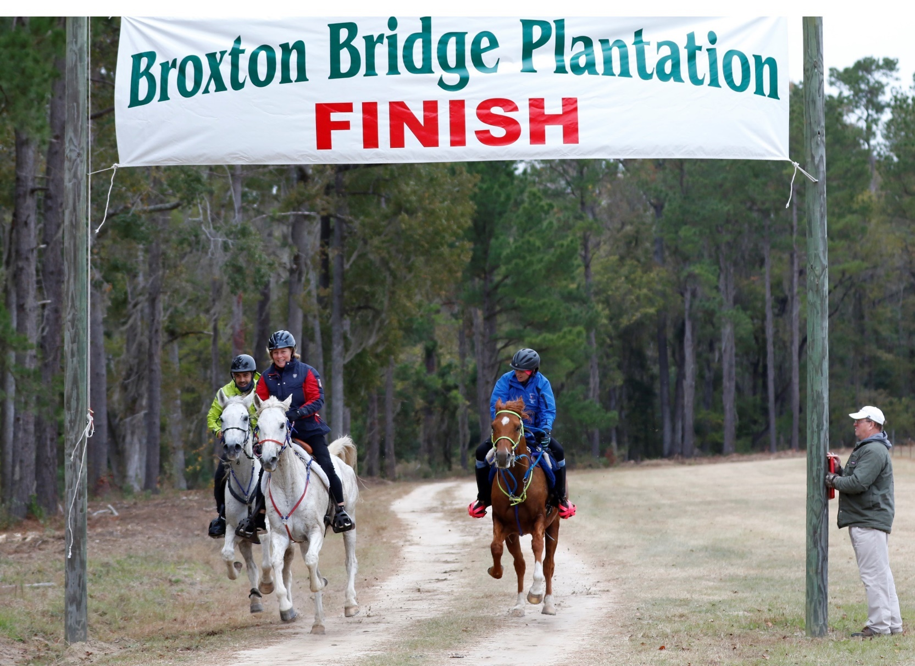

**(Photo: Becky Pearman)**

**Location**: Broxton Bridge is located 7 miles south of Ehrhardt, SC on Hwy 601, 12 miles north of Hampton on Hwy 601. GPS N32.59.989 W81.03.121 From the north, exit 57 off I95. From the south, I95 exit 38 towards Hampton. Call 803-267-3882 BBP or [www.broxtonbridge.com/directions.htm](http://www.broxtonbridge.com/directions.htm%20) [-](http://www.broxtonbridge.com/directions.htm). **Cell service is marginal after you leave town!** Internet is not good, but a Broxton Wi-Fi pass makes it workable near the vet check area. These passes may be purchased (business hours) at the Broxton office by the ice machine.

**Trails**: All trails are groomed hard and soft sand shaded primarily by pines and old growth hardwoods. There are plenty of water stops about every 4 miles on the trails and we’ll have coastal Bermuda hay at water stops on the later loops. Barefoot friendly for most distances.

**Distances:** Riders have 6 hours to complete the 25 miles, 7:15 for the 30-mile ride, 12 hours to complete the 50 miles, 15.30 hours to complete the 65 miles (104 km) 18 hours to complete the 75 miles (120 km). Please see the FEI draft schedule for loop lengths and hold times for each phase. It may be found at [www.usaseendurance.rocks](http://www.usaseendurance.rocks/) when approved, although weather may determine the actual start time each evening.

**Camping/Stabling/Corrals**: Covered corrals and corral panels are available. Covered corrals are $35 per night (VERY LIMITED NUMBER) and four-panel corrals are $16 per night. Panels will be available **for you to** **set-up** where you want them at your campsite. Use the on-line registration form to order panels as we may run out.

Remember, each horse owner, trainer and/or rider is responsible for safe camping and restraint of their horses. We thank those of you who rake up all hay/manure and put it into blue tubs – Broxton implemented a clean-up fee of $50 per campsite if you do not rake up hay/manure into piles and put into blue tubs. We are not the only people who love this place, and the motorcycle campers really appreciate clean grounds!

# Electric/RV Park/LodgingELECTRIC SITES ARE PRE-ASSIGNED although we have never run out and there should be campsites are available upon arrival that we can assign to you. We post and email the campsite numbers in advance ALTHOUGH THEY MAY CHANGE*!* To reserve an electric hook-up, do so online when entering the rides. *If* *you want to camp near your friends, put a note in the COMMENT area during registration online.* Full bath house on grounds. visit <http://www.broxtonbridge.com/>for additional details. Camp will open Friday, July 22 at 8 am. Early arrival primitive camping for $20 per night per trailer is available in designated areas for early arrivals or late departures. You must notify us in writing in advance if you are coming early and receive confirmation from us! YOU CANNOT CAMP BLOCKING ANY ELECTRIC HOOKUPS without paying the nightly rate for them. Historic lodges which are ON THE GROUNDS are $90 per room per night. LIMITED availability as we house our officials. For ROOM reservations (most rooms have shared bathrooms) call Cheryl at 386-566-4820 -Other lodging - Days Inn Hampton, SC 866-608-5966

**Registration/Fees:** All ride entries with payment must be received by 5 July. There is a $15 fee per ride charged for all riders who are not current members of AERC. **The introductory rides do NOT require AERC membership.** Bad check fee of $50 – we can hold checks for you as we understand cash flow but please ask in advance! FEI (Friday only) riders must also register through their NF online before the 7 July (3 pm) deadline.

**Cancellations**: Once you register online, there are no refunds. If you registered online and should have to cancel before arriving on site with 14 days’ notice as we have bought prizes and completion awards plus guaranteed food count, or did not vet in successfully, AERC entry fees will be credited towards a future Broxton ride within the next year, minus the $50 per ride administration fee plus camping. If you cancel with less notice than 14 days’ notice, we will keep your payment and only provide partial ride credit for Broxton ride within one year. If you register in the online registration system, you must CANCEL in writing – so that we are not expecting you. *If you cancel, you are still responsible for the 14-day cancellation fee even if you have not paid yet as we spent money expecting you, please.* No-shows/no-calls and withdrawals or pulls after crossing the start line will not receive any refunds. Meal tickets are non-refundable. Cancellations must be made in writing to [usaseendurance@gmail.com](mailto:usaseendurance@gmail.com) Everyone must pay any camping/electrical, panels, meal charges incurred also.

**Farrier and Vet Fees**: Riders are responsible for any individual farrier (if available) or vet services. Failure to pay any of these fees on site (or make arrangements) will result in any rider and/or owner not being welcome at future rides, forfeiture of points and qualifications and collection fees. **Junior Riders:** Riders must be accompanied by an adult 18 and over. **Everyone must wear a helmet when mounted.**

**Awards:** Daily completion awards to all. Top Ten awards for all distances along with First Junior, Middle of the Pack, Turtle and Best Condition for each distance.

**Food:** Each rider receives one meal ticket for the day(s) you are riding, it’s a late lunch. Lunch Meal tickets for additional days may be purchased for riders, owners, or crew on-line in advance to guarantee availability. Carol will have her great fresh cooked meals and sweets snacks for sale. Breakfast and dinners can be purchased in advance to guarantee availability or bought on site (if available).

**Vet in** is estimated from 1-2 and then 4:00 -5:00 pm the day of the ride. **The entry fee includes camping for one night. Early arrivals are welcome although you are responsible for additional primitive camping OR electric hookup fees for early arrivals or if you are there more than 1 night. The fee is $25 per night for primitive camping so please be straight with us!

**Please be nice** to our volunteers and officials, who we really appreciate; we could NOT

do this without help**!** Please help when you can! **Questions**? Contact Cheryl Van Deusen

at 386.566.4820 or usaseendurance@gmail.com

**Broxton Bridge: Night Riders! SANCTIONED BY AERC, SERA, SEDRA**

**Friday July 14 AERC 30, 50, 75, 100 Intro and CEI 1*, CEI 2*, CEI 3*+ YJ divisions**

**Saturday July 15 AERC 25, 50, and Intro**

*Current Coggins (within 12 months) required for travel to Broxton. Must be current member or pay $15.00 non- member AERC fee per ride except for Introductory Ride*

## ONLINE ENTRY for ALL rides: here

**ALL ENTRIES/PAYMENT MUST BE RECEIVED on or before 5 July 2023.**  All entries should be submitted online [–](http://rideentry.org/Broxton/) then mail in full payment ***- We must have you registered online no later than 5 July to avoid the $50 ride late fees per day– We can hold your check if you let us know!***

{ }25/30-mile LD ride Adult – $150.00 __________

{ }50-mile ride Adult – $150.00 __________

{ }65-mile ride Adult – $170.00 __________

{ }75-mile ride Adult $190.00 __________

{ }25/30-mile ride Junior Rider <16 years if sponsored $100.00 **__________**

{ }50-mile ride Junior Rider <16 years if sponsored $100.00 **__________**

{ }65-mile ride Junior Rider <16 years if sponsored $120.00 __________

{ }75-mile ride Junior Rider <16 years if sponsored $130.00 **__________**

{ } Intro rider any age First Ride $ 55.00 __________

{ } Intro rider any age SECOND INTRO Ride same day $ 45.00 __________

{ } AERC Non-member fee per ride (not necessary for intro) $ 15.00 __________

{ } Extra Meals Lunch Friday (Rider free) $ 15.00 __________

{ } Extra Meals Lunch Saturday (Rider free) $ 15.00 __________

{ } Friday Dinner Ticket $ 18.00 __________ MEAL PRICES NOT FINAL YET

{ } Saturday Dinner Ticket $ 18.00 __________

{ } Saturday Breakfast Ticket $ 12.00 __________

{ } Sunday Breakfast Ticket $ 12.00 __________

{ } Friday CEI 1* Senior $ see draft schedule

{ } Friday CEI 1* Young Rider $ see draft schedule

{ } Friday CEI 2* Senior $ see draft schedule

{ } Friday CEI 2* Young Rider $ see draft schedule

**LATE FEE $50 per entry if payment not received by 5 July $ 50.00 __________**

NOW EVERYONE -- PLEASE SIGN ALL WAIVERS ONLINE – EVERYONE MUST SIGN, NOT JUST RIDERS, BUT CREW, OWNERS, PARENTS, OFFICIALS, FRIENDS – ANYONE ON SITE MUST SIGN so bring hard copies for anyone who DID NOT COMPLETE AN ONLINE REGISTRATION. Thank you!

Broxton Bridge Liability Waiver / Hold Harmless Agreement –

ALL owners/ riders/crew/volunteers EVERYONE must sign!

The undersigned, as a guest, hereby assumes all risks incident to equine related activities on the property of Broxton Bridge and, in consideration of the premises, hereby waives any and all claims which he might hereinafter have against Broxton Bridge or any of its owners, officers, directors or agents, by reason of any injury sustained by him/her while participating in equine related activities or otherwise using said property. Further, the undersigned, in consideration of his/her invitation to participate in equine related activities on said property, hereby covenants and agrees to indemnify Broxton Bridge and its owners, officers, directors or agents, jointly and severally, from and against any and all liability, damage or expense incurred on account of any injury inflicted or caused by the undersigned upon Broxton Bridge property or its other guests or their property while participating in equine related activities on said property. By signing below, the undersigned acknowledges that he has read the “Rules” of Broxton Bridge and this waiver and understands its terms and that by accepting the invitation to be on the property of Broxton Bridge agrees to follow any and all rules promulgated by the owners, officers, directors or agents of Broxton Bridge as suggested.

Must be signed by all members of party making reservations, riders and non-riders. (Guardians are required to co-sign with minors on the same line below.)

Date

Date

Date

Date

**RIDE WAIVER**

As a participant in the Broxton Bridge Endurance Rides, I agree to abide by the Rules of AERC, SERA, SEDRA and the aforementioned ride. I understand that endurance riding involves being in remote areas for extended periods of time, far from communications, transportation, and medical facilities; that these areas have many natural and man-made hazards which ride management cannot anticipate, identify, modify, or eliminate; that horses can be excitable, difficult to control, and unpredictable; and that accidents can happen to anyone at any time. I agree to take full responsibility for myself and the animal I am riding. I will hold AERC, ride management, all ride personnel, and all property owners over whose land the ride passes blameless for any accident, injury, or loss that might occur due to my participation in this ride, and free from all liability for such injury or loss. Junior riders (under 16 years as of the first day of the current ride season) entered in the ride will be accepted and allowed to ride only if accompanied by an adult rider (21 or over). Juniors will not be allowed to start or continue from any point without an adult sponsor. JUNIOR RIDERS MUST WEAR PROTECTIVE HELMETS. I HAVE READ THE RULES, CONDITIONS AND REGULATIONS OF THIS RIDE AND WILL ABIDE BY THEM. PARENT/ GUARDIAN SIGNATURE GIVES PERMISSION FOR EMERGENCY MEDICAL TREATMENT FOR JUNIOR. Rider’s

Signature & Name___________________________________________________Date_____________

Parent/Guardian Signature___________________________________________ Date_____________

Signature & Name of Sponsor/Crew____________________________________ Date_____________